**[Assignment 3]**

The Minesweeper plate problem

**[Description]**

The Minesweeper game is one of the basic games included in Microsoft Windows from version 3.1 to version 7. The player is initially presented with a plate consisting of several square buttons. Each button can be opened by pressing. If you open the button with the mine hidden, the game is over. If it is a button without a mine, the number of hidden mines around the button is written.

Write a program which makes a 10x10 Minesweeper plate. (You need not to make a real game. Just print the plate.)

Notice that

1. Make two-dimensional array to use as Minesweeper plate. Size of it is 10x10.  
   All of its elements must be initialized to 0.
2. Using file I/O, open the "index.txt" file which is uploaded on I-campus. Read the first line containing an integer value N, representing the number of a pair of row index and column index. It is followed by N lines, left value of each is row index and right value of each is column index. You must read and display these pairs.
3. In the two-dimensional array, store -1 at the space(position) which is indexed by row index and column index pairs from the file read process. The value -1 is identified as a mine.
4. For each space which has no mine, count the number of mines in any of the eight directions (left, left-top, top, right-top, right, right-bottom, bottom, left-bottom) around the space. We call the count the number of surrounding mines.
5. Display two case of the plate: Before counting mines and After, like the following examples.

**[Example]**

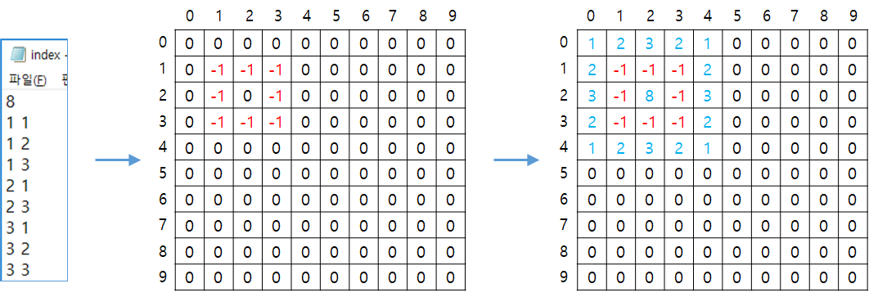

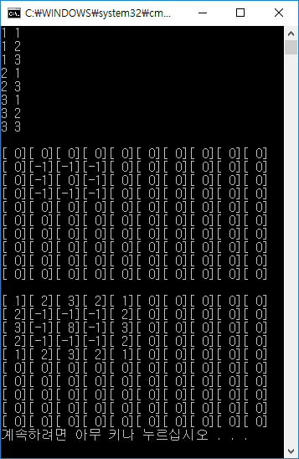

**[Rating]**

* Total points = 100.
  1. Make two-dimensional array to use as Minesweeper plate. Size of it is 10x10.   
     All of its elements must be initialized to 0. (10 points)
  2. Using file I/O, start the read process of the "index.txt" file which is uploaded on I-campus. (10 points)
  3. Read all row index and column index from the text file and display them as shown in the example above. In the text file, first line contains an integer value N, representing the number of a pair of row index and column index. In the following N lines, left value of each is row index and right value of each is column index. (25 points)
  4. In the two-dimensional array, store -1 at the space(position) which is indexed by row index and column index pairs read from 3). Display the plate as shown in the example above. (25 points)
  5. For each space which has no mine(the value -1), count the number of mines in any of the eight directions (left, left-top, top, right-top, right, right-bottom, bottom, left-bottom) around the space. We call the count the number of surrounding mines. Finally, Display the plate as shown in the example above. (30 points)
* Delay penalty: After due date, 15 points will be deducted for every single day. And submission will not be entertained after 3rd day.
* Submit the successfully compiled source code on I-Campus.
* If you have a question about assignment, send e-mail to kbs2375@naver.com (Make sure write your name and the point what you want to ask.)